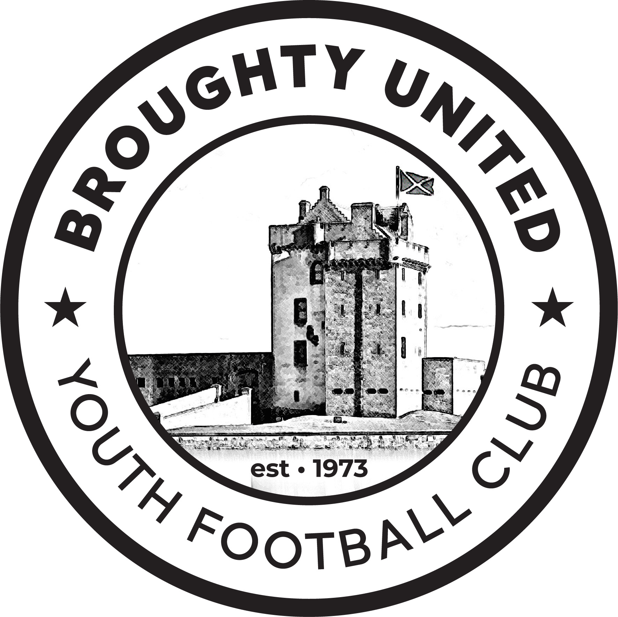
Social MediaPolicy
Broughty United Community Club SCIO
Last updated | 12/01/2026

Purpose of this policy
The purpose of our Social Media policy is to ensure that Club members make appropriate decisions about the use of social media such as social networking websites, podcasts, forums, message boards, or comments on web-articles, such as Twitter, Facebook and LinkedIn.
This policy outlines the standards we require our Club to observe when using social media, the circumstances in which we will monitor your use of social media and the action we will take in respect of breaches of this policy. This policy supplements the Club’s Disciplinary Policy.
Who is covered by the Policy?
This policy covers all individuals involved at all levels, including Trustees, general committee members, managers / coaches, staff, volunteers, players and parents/carers.
Scope of the Policy
All members are expected to comply with this policy at all times in order to protect the privacy, confidentiality, and interests of our Club and our sponsors.
Breach of this policy will be dealt with under our Disciplinary Policy and, in serious cases, may be treated as misconduct leading to a formation of a Discipline Committee and actions such as suspensions or dismissal from the Club.
Responsibility for implementation of the policy
The Trustees have overall responsibility for the effective operation of this policy.
The Club Secretary and Social Media Secretary are responsible for monitoring on a day to day basis and will review the operation of this policy and making recommendations for changes to the Trustees.
All Trustees, general committee members, managers / coaches, staff, volunteers, players and parents / carers are responsible for their own compliance with this policy and for ensuring that it is consistently applied. They should ensure that they take the time to read and understand it. Any breach of this policy should be reported to the Club Secretary.
Using social media sites in our name
Only the Social Media Secretary/website designer and persons designated by the Executive Committee is/are permitted to post material on a social media website and website in our name and on the Club’s behalf. Any breach of this restriction will amount to misconduct.
The Club recognises the power of social media to keep us connected with our members and to build our profile within the community. Regardless of the social media site members are using we recommend
- Members understand the site they are using by becoming familiar with the social network before contributing.
- If unsure, don’t post it. Members should err on the side of caution when posting to social media. If you feel that a message or update may cause offence or complaints, don’t post it.
- Be polite and thoughtful. Many social media users have got into trouble by failing to observe good manners online. Employ the same level of courtesy when communicating club business via email.
- Don’t make promises without checking. Social Media can be very public, so don’t make promises or commitments on behalf of the club without first checking that we can deliver. Direct any enquiries to the Social Media Manager.
- Handle complex or sensitive matters via other channels. Social Networks are not a good place to resolve complicated or sensitive matters. Once an initial contact has taken place, resolve the enquiry via the most appropriate channel – usually email or telephone.
- Think before you respond. It is easy to escalate matters unnecessarily by posting a quick response to a contentious posting. Take the time to think before responding, consult the Social Media Manager if necessary and hold back if you are in any doubt at all.
Monitoring use of social media websites
All members of Broughty United Community Club SCIO should be aware that any use of social media websites will be monitored and, where breaches of this policy are found, action may be taken under the Clubs Disciplinary Policy.
Uploading, forwarding or posting a link in regards to Broughty United Youth Football Club to any of the following types of material on a social media website will amount to misconduct.
- pornographic material (that is, writing, pictures, films and video clips of a sexually explicit or arousing nature);
- a false and defamatory statement about any person within the Club;
- material which is offensive, obscene, criminal discriminatory, derogatory or may cause embarrassment to the Club, Trustees, general committee members, managers / coaches, staff, volunteers, players and parents / carers;
- confidential information about the Club or any person associated with the club who has not given express authority to disseminate;
- any other statement which is likely to create any liability;
- material in breach of copyright or other intellectual property rights, or which invades the privacy of any person.
Any such action will be addressed under the Disciplinary Policy. If you notice any use of social media by other members of the Trustees, general committee members, managers / coaches, staff, volunteers, players and parents / carers in breach of this policy please report it to the Club Secretary.
Trustees, Coaches, Volunteers, Staff must not
- Use text or emails for personal conversations, sending pictures, jokes or other items of a personal nature or engage in any ‘banter’ or comments with or about children at the club.
- Use internet or web based mobile phones or other form of communications to send personal messages of a non-football nature to a child or young person.
- Respond to emails or texts from young people other than those directly related to club matters.
- Use language that is directly (or could be misinterpreted as being) racist, sexist, derogatory, threatening, abusive or sexualised in tone.
- Accept as a friend, young players or any person employed or volunteering at the club who is U18 on social networking sites.
- Share your own personal social networking sites with children or young people involved at the football club or ask them to be your ‘friend’.
- Make contact with children or young people known through football outside of the football context on social networking sites.
- Post personal comments in relation to the management or operation of the club, club officials. match officials, children, parent/carer or opposition teams or any family members of those groups.
- Share or link to data in any way that could breach the club’s Data Protection Policy.
- The club’s Social Media accounts must be protected by strong passwords which are not shared with unauthorised users.
- Delete any inappropriate text or email messages sent to you as they may form part of any subsequent investigation.
Parent Guidance. Parents should: -
- Know who the club Child Protection Officer is and how to contact them if you have any concerns about the content of club web pages or in relation to the welfare of your child
- Ensure you are aware of how coaches, managers and other members of the club should communicate with your child
- Show an interest in the communications between the club, you and your child. Open communication about club activities/issues often means that concerns are picked up early and issues can be resolved more easily
- Familiarise yourself with Scottish Youth Football Association’s guidance for clubs in relation to websites, text messaging and social networking sites
- Understand the club’s communication practices.
- Ensure your child understands that they should tell someone that they trust about communications that make them feel uncomfortable or when they’ve been asked not to tell their parent/carer or coach about the communication.
- Remember as a parent/carer of a child at the club you and your child are responsible for and need to abide by the club policy and the SYFA Policy regarding comments that you place online about the club or club officials, the SYFA, the DDYFA, players, managers, match officials, opposing teams players or family members of any of those groups
- Inform the club’s Child Protection Officer as soon as possible if you or your child receives any inappropriate communication from any member of staff/volunteer or other person associated with the club and save the communication
- Parents must not use social media to speak ill of the club or any staff or associates or to comment on players, training or matches.
- Parents must not reveal any information they may have received about a player.

Player’s Guidance. Players must not: -
- Post, host, text or email things that are hurtful, insulting, offensive, abusive, threatening, or racist as this would go against Broughty United Youth Football Club’s rules and could also be against the law. Neither should they post personal comments in relation to the management or operation of the club, club officials, match officials, players, opposition team member(s), or any family members of those above.
- Engage in any personal communications, ‘banter’ or comments with staff / volunteer(s), players’ opposition teams.
- Give out personal details online including mobile numbers, email addresses or social networking account access to people you don’t know well offline
- Invite any adult involved with the club to become your friends online, or accept them as a friend on any social network site. They have been told they must not to accept such invitations
- Use internet, web-based, phone or any other form of communication to send personal messages of a non-football nature to any member of staff/volunteer at the club
- Delete inappropriate text or email messages sent to you as they may form part of any subsequent investigation
- Use inappropriate language.
- Reveal information about training, fixtures and contractual agreements etc using social media posts.

Monitoring and review of this policy
This Code is fully supported by the Trustees of Broughty United Community Club SCIO who are responsible for its implementation and regular review.
If you have any questions about this policy, please contact the Club Secretary.
END OF POLICY

